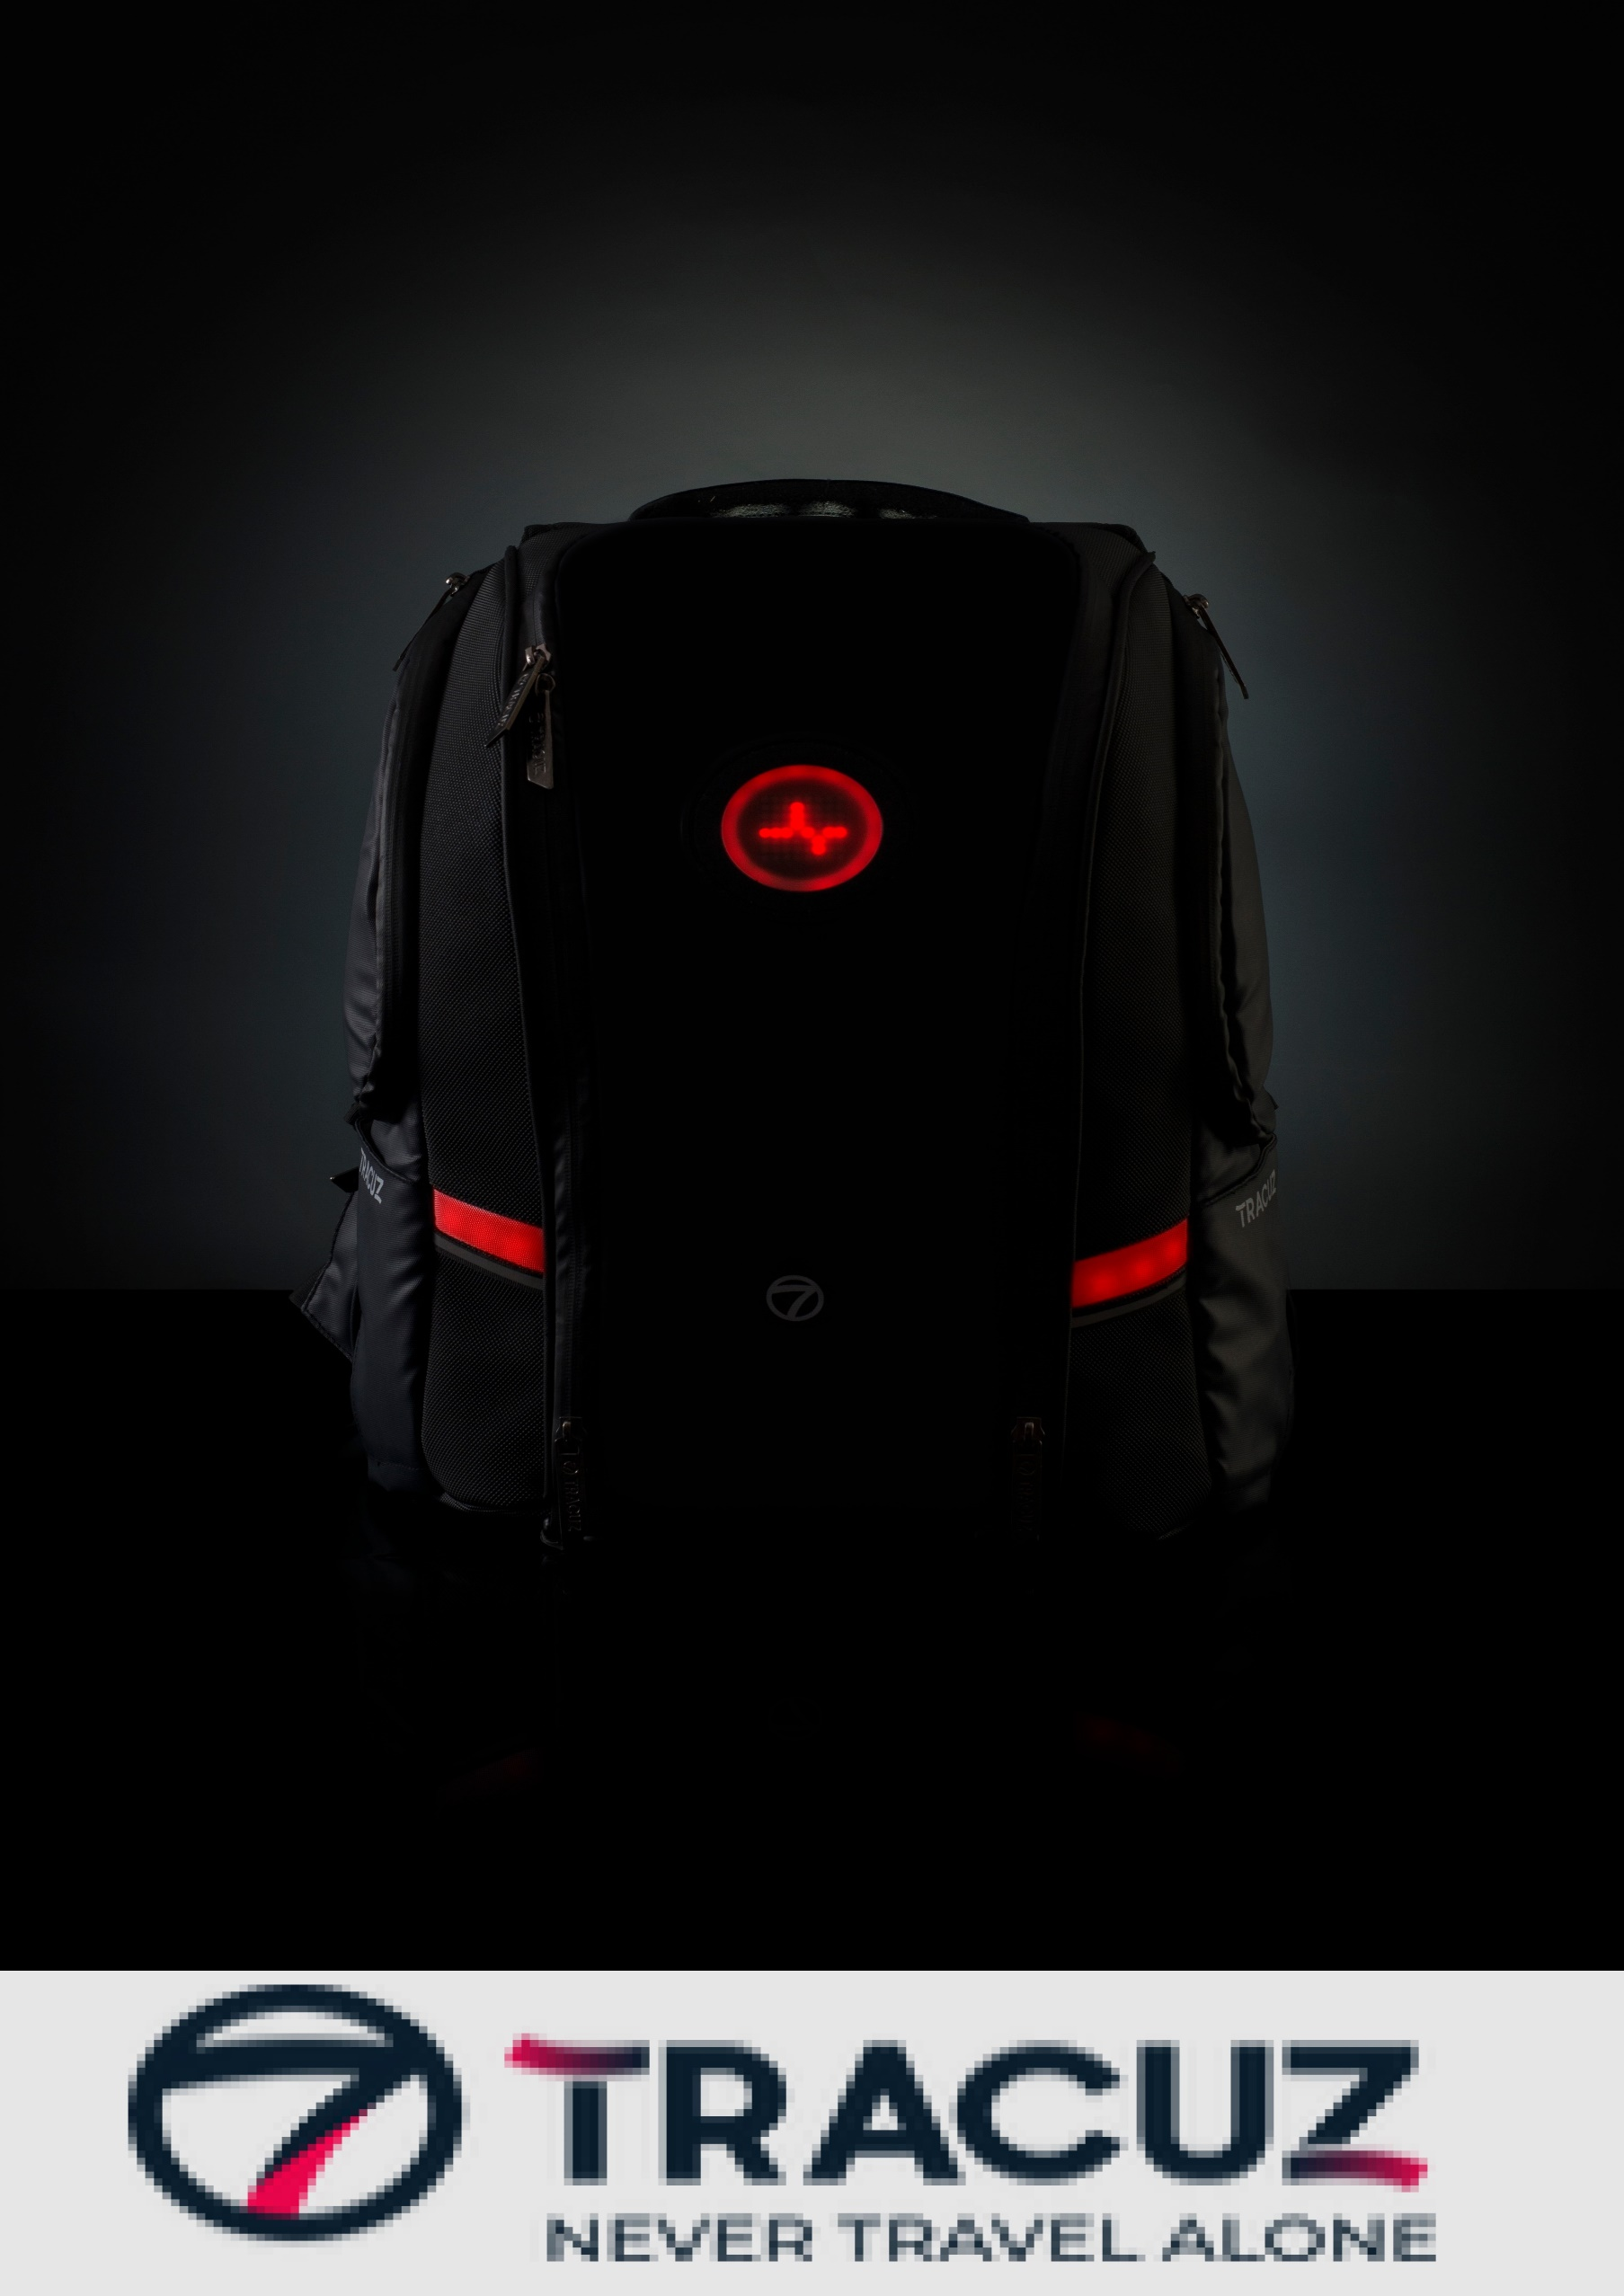

Tracuz bag

User Manual

www.tracuz.com

Contents

What’s included? 3

Starter guide 4

Compatibility 4

Download and Install the APP 4

Instructions to be followed 6

Features 7

Inner Illumination 7

Deep Sleep 7

Predefined Animation 7

Custom Animations 7

Text Display 7

Secure Mode 8

Silent Mode 8

Ride Mode 8

Beacon Tracking 8

Bluetooth Control 8

Pollution level monitoring 9

Button Controls 9

Recharging 11

Troubleshooting 11

CAUTION 12

Warranty Details 12

Warranty Duration 12

What does the limited warranty cover? 12

What will we do to correct the problems? 13

What does this limited warranty not cover? 13

HOW TO OBTAIN WARRANTY SERVICE? 13

Contact details 13

**Welcome note,**

Hi, thank you for choosing TRACUZ and welcome to our family. Plugin the power bank to the cable which is provided inside the bag and you are all set to start with.

For more information

Visit our official website: www.tracuz.com

# What’s included?

**_____**

|  |  |
| --- | --- |
| **Quantity** | **Items** |
| 1 | Tracuz bag |
| 1 | Bottle pouch |
| 1 | Inner compartment bag |
| 1 | Coin pouch |
| 1 | Beacon |
| 1 | Power bank |
| 1 | Charging cable, power bank cable |
| 1 | User guide |
| 1 | Product QR code |

# Starter guide

**_____**

Open the Tracuz bag and plug in the power bank, check if the front led part lights up. If that is happening you are all set to use the bag. You can either use the bag standalone or you can use it interfacing with the app.

## Compatibility

Blend With Any Phone,

1. Compatible to any Android device running Tracuz App
2. iPhone compatibility coming soon.

## Download and Install the APP

1. Go to play store and install TRACUZ app.



1. Now take the QR code which is provided inside the box and scan it.

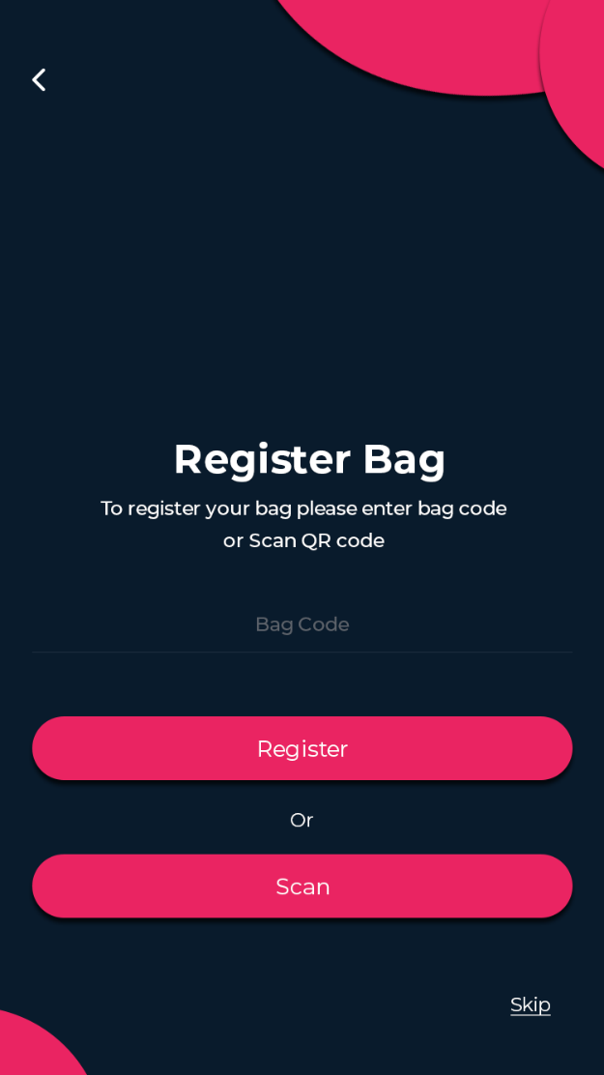****

1. So, now you will be registered. Make sure to connect your mobile to the bag through Bluetooth for the extensive experience.

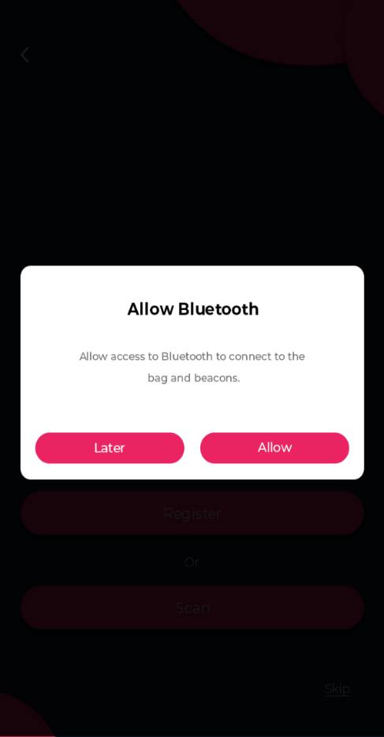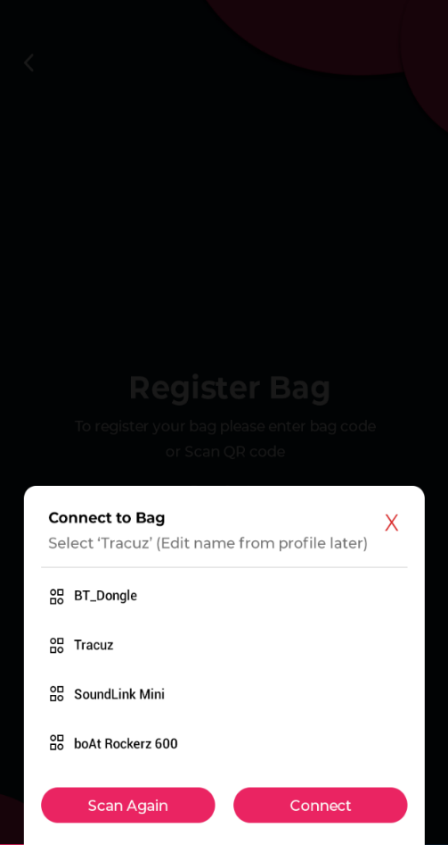

1. Both the bag and app is connected no you’re ready to travel.

# Instructions to be followed

**_____**

1. Make sure the power bank is fully charged before using it for powering up the bag to get the most appropriate battery percentage in the app.
2. Make sure to set the time again when you return from deep sleep mode.
3. Try to handle the bag with care for a longer lifetime.
4. Do not try to hard press the buttons which may lead to malfunctioning later.

# Features

**____**

## Inner Illumination:

There are LEDs placed inside the bag which illuminates in the dark when the zip is opened. It lights up for 15 seconds after which it shuts down.

## Deep Sleep:

The deep Sleep functionality allows the user to save power by turning off the other functionalities like sensors, front matrix LEDs and other LEDs.

## Predefined Animation:

There are set of 25 predefined animations which can be displayed on the 8*8 LED Matrix display along with addressable LEDs with custom colour. Changing the Predefined animation with the addressable LEDs colour can be done through the app.

## Custom Animations:

The custom animation can be set by the user and he/she can any kind of animation and save it in the app. Creating custom animation can be done through the app.

## Text Display:

The rolling text can be sent through the mobile app and is displayed on the 8*8 LED Matrix along with addressable LEDs with custom colour.

## Secure Mode:

The secure mode is a virtual lock for the bag. In secure mode, the zip state is checked continuously to find any disruption in the previous state and also alerts if someone tries to take the bag and go which is left down. The bag will alert the user if there is a disruption.

## Silent Mode:

The silent mode turns the bag to silent mode by turning off all the audio notifications by keeping haptic notifications on.

## Ride Mode:

The ride mode turns on the navigation by visual as well as haptic notification. The ride mode is specifically designed for cyclist with turn indicators. In ride mode pollution level will be monitored each and every second and the ride will be alerted with pollution data.

## Beacon Tracking:

The Beacon is a small Bluetooth radio transmitter. The beacons can be added to valuable items like wallet, house keys, laptop, tag etc to enable their tracking. The bag will notify the user if there is any missing item.

## Bluetooth Control:

The functionality of the bag can be operated through the mobile application using Bluetooth connectivity and also bag can be used standalone too.

## Pollution level monitoring:

The Pollution sensor data is stored in the bag. It alerts you if the pollution level goes beyond some threshold point.

# Button Controls

**____**

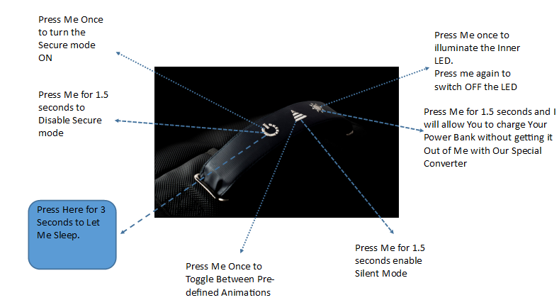

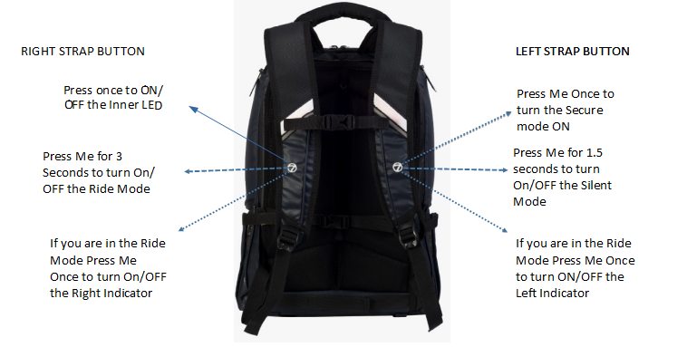

|  |  |  |
| --- | --- | --- |
| **Buttons** | **Timing state** | **Functionality** |
| **Power button(strap button, left most first one)** | Press once | Press once to enable secure mode |
|  | Press & hold for 1.5 seconds | Disable secure mode |
|  | Press & hold for 3 seconds | Enter deep sleep mode |
| **Triangle button(Strap button, Middle one)** | Press once | Press once every time to toggle between animations |
|  | Press & hold for 1.5 seconds | To enter into silent mode |
| **Light button(Strap button, Right most third one)** | Press once | ON/ OFF the LED inside bag |
|  | Press and hold for 1.5 seconds | Trigger the power bank to charging mode |
| **Left strap button** | Press once | Enable secure mode |
|  | Press and hold for 1.5 seconds | Enter into the silent mode |
| **Right strap button** | Press once | To switch OFF/ ON the inner LED |
|  | Press and hold for 3 seconds | To switch OFF/ ON ride mode |
|  | Press once when ride mode ON | Left strap one press indicator ON/OFF |
|  | Press once when ride mode ON | Right strap one press indicator ON/OFF |

# Recharging

**____**

Superior Quality and Texture,

1. Retract USB charging/discharging cable accessory, a single cable solution
2. Manually charge through low powered sources too
3. Plug your charging cables in the USB port
4. Charge any 5V USB (Mobile, tablet and type C laptops) device on the go.

Press and hold the 3rd strap button (LED illumination one) for 1.5 seconds so, the power bank will turn to charge mode.

# Troubleshooting

**____**

1. If you find that the buttons aren’t working or if you find any abnormalities in the functionalities try to plug out and plug in the power bank.
2. If the bag is not powering up try to change the power bank and try it out.
3. If you find any part or functionality not working feel free to call or email our support team.

# CAUTION

**____**

1. Do not try to wash the inner part of the bag to avoid electronics failure.
2. Do not try to open the electronics part of the bag to avoid malfunction.
3. Do not use coarse cleaners to clean your bag.
4. Charge the battery by following the instructions supplied with this guide.
5. Never allow children to play with the bag; the small components may be a choking hazard!
6. Follow the recharging guide which is provided do not try it on your own.
7. Do not allow your bag to be submerged in water it’s water-resistant, not water-proof.

# Warranty Details

**____**

## Warranty Duration:

Thank you for your interest in getting Tracuz bag

The TRACUZ bag has limited warranty, 2 years for the fabric and stitching and 3 months for the electronics.

## What does the limited warranty cover?

The Limited warranty covers any defects in material or workmanship under normal use during the warranty period.

During the Warranty period, Tracuz will repair or replace, at no charge, products or parts of a product that proves defective because of improper material or workmanship, under normal use and maintenance.

## What will we do to correct the problems?

Tracuz will either repair the product at no charge, using new or revamped replacement parts.

## What does this limited warranty not cover?

The limited warranty does not cover any problems that are caused by, damage not resulting from defects in material or workmanship

## HOW TO OBTAIN WARRANTY SERVICE?

To obtain warranty service, you must first contact us to determine the problem and the most appropriate solution for you.

# Contact details

**____**

|  |  |
| --- | --- |
| Address | 410, Vijetha Apartments,  4th Floor, Brookefield, Bangalore-560037 |
| Phone number | +91- 7406511990 |
| Email ID | [go@tracuz.com](mailto:go@tracuz.com) |